|  |
| --- |
|  |

[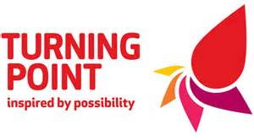](http://www.bing.com/images/search?q=turning+point+&view=detailv2&adlt=strict&id=ECCC3A5D7E1E147A7E597690595E483641DA24EF&selectedIndex=6&ccid=Zl8Fqh07&simid=608002074178750458&thid=OIP.M665f05aa1d3bf894351d9004296dda40o0)

Fact Sheet

Recovery Community Fund

**Recovery Community Fund Fact Sheet**

Do you live or work within Suffolk East Anglia? Do you have a passion for improving the wellbeing of people in recovery within the local area?

You provide the big idea; we provide any amount up to **£5000** to help make it happen.

The Recovery Community Fund

We are looking for innovative ideas that enhance the lives of our service users and members of the local communities in which we operate by:

* Reducing social isolation both locally and for people who access our services and
* Encouraging personal growth within the 5 Ways to Wellbeing

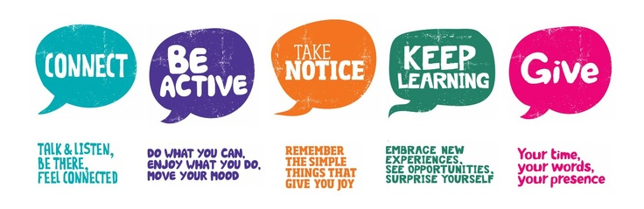

*Try something new; learn a new skill, take up a hobby.*

*Try volunteering; give your time to help others.*

*Try volunteering; give your time to help others.*

*Keeping fit, going for a walk, improving your mood*

*Social activities meeting new people, feeling less lonely.*

Funding Deadlines

The funding panels sit on the first Tuesday of the month to discuss grant applications. We will aim to give you as much notice as possible when inviting you to attend one of our panels to present your ideas.

The possibilities are endless…

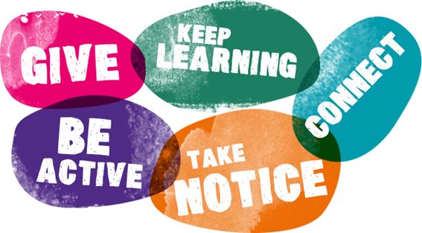

Using the skills of the community and local resources to create upcycling and mending workshops

A regular social space for people with shared interests (like fishing or baking) to get together and make new friends

**Organise a volunteering activity where anyone can give their time and have fun, like decorating a community space or community gardening!**

Create a walk that both gets people together and takes them past local community centres and through our lovely parks



It would be good to have a sports buddy, someone I can try different sports with

How much can be applied for?

We have a funding for any amount up to £5000.

Each grant must be spent within 12 months of the grant being allocated.

**If you are currently in receipt of any benefits and you are awarded a grant, it is important that you have a conversation with the Department of Work and Pensions to ensure that you are not penalised in any way.**

**Who can apply?**

We are looking for projects from residents (aged 18+), charities and not-for-profit groups located within the county of Suffolk, England.

What the fund can / cannot be used for

|  |  |
| --- | --- |
| Can be used for | Cannot be used for |
| One-off or regular activities that promote social inclusion, such as setting up a weekly shared interest group or organising a one-off event.  For example: you are interested in setting up a regular mindfulness group in Suffolk as you’ve realised nothing currently exists. You need funds to pay for the initial space and promotional material. | Salary and staffing costs. |
| Costs occurred through application |
| Items/projects that only benefit an individual rather than a group of people. |
| Loans or interest payments |
| Political or religious activities |
| Projects that you cannot maintain because of high on-going costs or the need for specialist skills |
| Projects that cannot take place within the funding window. |
| Equipment or resources to aid current provision that supports people in recovery.  For example: you currently provide a local not-for-profit voluntary service providing food parcels and a friendly chat to homeless people in the local area. You would like funding to train five new volunteers. | Projects that are based outside of Suffolk. |
|  | The purchase of alcohol or illicit substances |

Insurance and safety

Depending on the type of project, you may need public liability insurance or qualified leaders. It is your responsibility to ensure you have adequate insurance in place. This should include cover for any assets you buy or events and activities you run using our grant. We may ask to look at these policies at any time. Your organisation must be affiliated to a governing body if your project involves a dangerous sport or activity

Bank or building society account requirements

* You must have a UK-based bank or building society account in the name of the organisation that submits the application and will carry out the project.
* We may ask you to open a new and separate account that will only be used for our funding.
* We are unlikely to fund a group or organisation which is in poor financial health.

Bank statements

* Any bank statements that we ask for should show your organisation’s name and address. These must be consistent with the details provided in the application form or information elsewhere in the public domain.
* Your bank statement should show that your account is being managed in line with your own financial procedures and our programme requirements.

Signatories

* The people named as contacts on the application and any other form should be fully aware of the application and the project. We need full legal names as shown on identification documentation (such as passports, immigration documents, driving licences), not alternate names that they may be known by, should be included. Written signatures, if included, should match those on other legal documents.

Monitoring your grant

If we fund your project we will meet with you on a regular basis to check how your project is progressing, confirm how the grant has been spent and what you have achieved. If you are funding a one-off event or activity, we will ask you to complete our recovery community fund reporting pack. If you are undertaking a lengthy project, we will also contact you six and/or twelve months after completion to understand the legacy effect of our funding - whether it is still running and what effect it has had in the community.

Please obtain and keep receipts for all items or services you buy with the grant as we may ask you to provide them. Please inform us if your project or any of your contact details change at any stage of your grant.

Repeat Applications

We will look at each new application on its own merit, but if you are applying for an existing projects, we may ask some additional question.

Further questions

If you have any questions please call Stephanie Sattaur on **07354168949** or email us at [recoverycommunityfund@turning-point.co.uk](mailto:recoverycommunityfund@turning-point.co.uk)

The application process

Complete your application form

When you are ready to make an application, fill in an application form and send it to us. Make sure that you leave plenty of time for your application form to get to us before the deadline.

Please make sure that you have completed the whole of the application. Incomplete applications will not be considered.

**We assess your application**

We will assess your application and may to come back to you for more information or to expand on some of your answers.

If you are currently accessing support from one of the local services we may at this stage ask to have a brief meeting with you and your keyworker to ensure that you are receiving all of the support that you might need during this process.

All applications that are assessed as having adequate information and meeting the criteria will then be put through to the decision panel made up of a mix of service users and local community members. You will probably be asked to make a brief presentation of you project to the panel.

**A decision is made by the Panel**

The types of decision that may be taken by a decision making board include:

|  |  |
| --- | --- |
| **Award in Full** | The award is made at the level requested in the application. |
| **Reduced Award** | The award is funded but at a reduced level. In this situation you may be asked for evidence that you are able to obtain the rest of the funding from other providers. |
| **Deferred Award** | The panel may withhold a decision in order to seek more information. The application will return to the next meeting for a final decision. |
| **Rejected** | The application is not funded. |

**If you are successful** If you are not successful

Depending on the amount and purpose of money that has been applied for you may receive the grant in regular instalments.

You will be required to provide regular progress reports throughout the period that your project is operational.

We will support you with any help that you might need to reapply in the future.

**Useful Information**

Our services

**Suffolk Drug and Alcohol Service** is offering support to adults, young people and families when and where they most need it. Our services are free.

We understand that drugs and alcohol can affect many areas of your life. At Turning Point, we get to know you as a person, to understand exactly what you need to start your recovery and live a healthier life. There are many paths to a life free from drugs and alcohol and together we can find the path that's right for you.

[Suffolk Drug & Alcohol Service | Turning Point (turning-point.co.uk)](https://www.turning-point.co.uk/services/suffolk-drug-and-alcohol-service)

**Funding Guidance:** Every year, The Big Lottery distribute millions of pounds of the National Lottery's good cause money to community groups and charitable projects around the UK. They also have a number of online resources available for people applying for funds

<https://www.biglotteryfund.org.uk/funding/funding-guidance/applying-for-funding>

**5 Ways to Wellbeing-** There are a number of great resources available regarding the 5 ways to wellbeing have a look at the Mind Website:

<http://www.mind.org.uk/workplace/mental-health-at-work/taking-care-of-yourself/five-ways-to-wellbeing/>